1. In the below elements which of them are values or an expression? eg:- values can be integer or string and expressions will be mathematical operators.

\*

'hello'

-87.8

-

/

6

Ans:

\* = expression

'hello' = value

-87.8 = value

- = expression

/ = expression

+ = expression

6 = value

2. What is the difference between string and variable?

Ans:

String: We can write string in quotes

for example: "Amey",'Amey'

Variable: Variable is a thing in which we can store data just like a container

for example: a=5, so (a) is storing data that contain (5)

3. Describe three different data types.

Ans:

List : A list is used to store multiple data items in a single variable.

Integer : An integer use to store only numerical values.

Float : A float can store only floating values like: 2.3, 6.88 etc.

4. What is an expression made up of? What do all expressions do?

Ans:

Expression is a thing that made up of values, various mathematical operations and containers as well.

For example: q=1+2, Expression is thing which is used to evaluate the values result on the screen.

5. This assignment statements, like spam = 10. What is the difference between an expression and a statement?

Ans:

Expression is a thing that made up of values, various mathematical operations and containers as well and the statement is just like a command that a python interpreter executes like print.

6. After running the following code, what does the variable bacon contain?

bacon = 22

bacon + 1

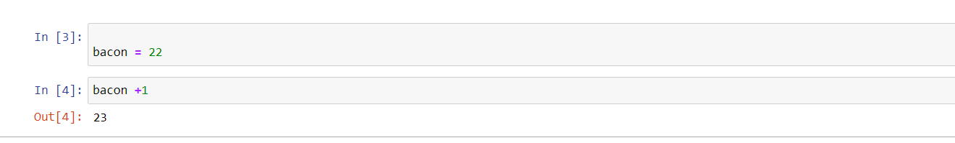

7. What should the values of the following two terms be?

'spam' + 'spamspam'

'spam' \* 3

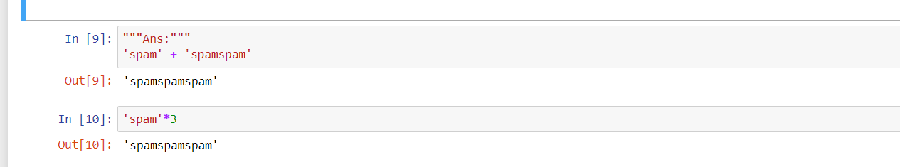

8. Why is eggs a valid variable name while 100 is invalid?

Ans:

Beacuse we can't start giving variable an integer name it will give an error. We should begin with, a string like alphabet name then an integer. For Example: iNeuron123 or Amey3334

9. What three functions can be used to get the integer, floating-point number, or string version of a value?

Ans:

integer: int()

floating-point number: float()

string: str()

10. Why does this expression cause an error? How can you fix it?

'I have eaten ' + 99 + ' burritos.'

Ans:

An expression cause an error because 99 is an integer it cannot be concatenated with string, if we have to conacatenate it we need to do typecasting in it.